**Burning Man**

**What is Burning Man?**

Burning Man resembles a festival, but the event can better be described as a countercultural arts event spanning about nine days. Burning Man is a surreal, dusty and quirky party in the desert of northwestern Nevada. The event is known for its eccentric displays of art and expression, including fantastical, arty vehicles; towering metallic sculptures; and whatever else its devotees can dream up. Burning Man is also well-known for its more hedonistic aspects, including sex, nudity and drug use.

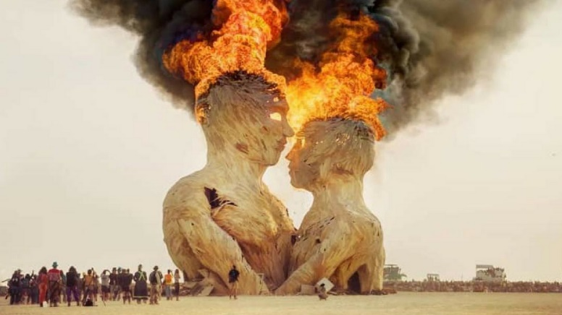

**Why is it called Burning Man?**

Burning Man takes its name from a giant, humanesque sculpture that is the centerpiece of the annual event – and changes in appearance year to year. Called The Man, the sculpture is ignited and burned to cap off the event.

**What are the origins of Burning Man?**

What is now known as “Burning Man” began in 1986 in Baker Beach in San Francisco. Founders Larry Harvey and Jerry James created an event centered on the burning of a human-shaped sculpture. During the 1990s, Burning Man exploded in popularity and was moved to the Black Rock Desert in Nevada, where it remains.  Briefly, the name was changed to the Black Rock Arts Festival before settling back to “Burning Man.”

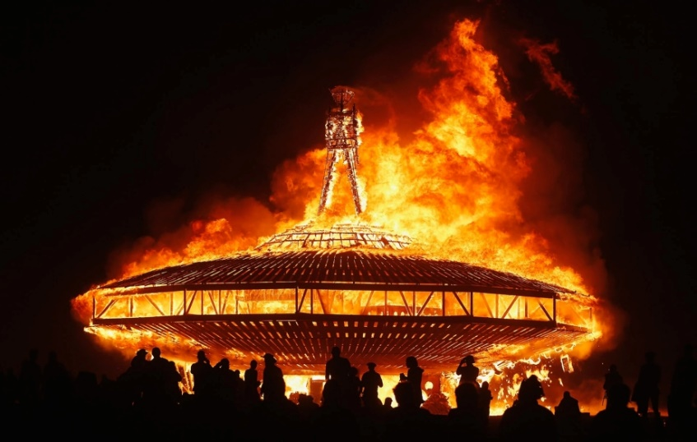

**What is the purpose of Burning Man?**

Burning Man is all about self-expression and the rejection of corporatism and capitalism. The experience of creating and viewing art and living in the moment is Burning Man’s purpose. Attendees famously create a fleeting, self-sustaining community that (theoretically) leaves no trace or trash upon its completion. A key theme of the Burning Man experience is the use of borrowing, bartering and trade in lieu of money exchange.

**What happens at Burning Man?**

About 80,000 people, known as “Burners,” make the annual trek to a harsh stretch of northwestern Nevada and set up a massive-yet-makeshift encampment dubbed Black Rock City. They build elaborate villages, a medical center, an airport and performance stages. From there it gets weird, but that is the point. Over the course of about nine days, attendees test the limits of self-expression through art, costume and design while building community and what they tout as a kind of utopia. However, the encampment is not without its problems, including drug use, arrests and sexual assaults. Law enforcement officers patroling the area include local deputies and federal agents as well as Burning Man’s volunteer Black Rock Rangers.